Website Technical Specification
Enterprise AI Hardware Procurement Platform
1. Business model
The website operates as a B2B AI hardware sourcing and procurement platform.
The company connects qualified enterprise buyers with U.S. suppliers of AI accelerators, GPU servers, and data-center infrastructure.
The website does not promise inventory ownership, fixed delivery dates, or authorized reseller status unless separately verified.
2. Product categories
- AI GPU Accelerators: NVIDIA Blackwell and other supported GPU products.
- AI Servers: GPU servers from approved manufacturers.
- AI Clusters and Racks: Multi-server infrastructure.
- Networking and Data Center Components.
- Custom Enterprise Procurement.
3. Product catalog
Each product record should support:
- Manufacturer
- Product name
- Manufacturer part number (MPN)
- SKU
- Product category
- Product description
- Technical specifications
- Approved product images
- Supplier reference
- Public price, if authorized
- Estimated lead time, if supplied
- Last data synchronization timestamp
- Quote request availability
Do not publish supplier cost prices, customer-specific pricing, or confidential inventory data without permission.
4. Lead-time display
The system must distinguish between:
- Supplier-confirmed estimated delivery date
- Supplier-provided lead-time range
- Product ordered with an estimated arrival date
- Lead time requiring confirmation
- Quote-only product
Every displayed estimate must include its source and last-updated timestamp where available.
Never convert missing supplier data into an invented delivery estimate.
5. Ingram Micro integration
Use the official Ingram Micro Reseller APIs, subject to account eligibility and production approval.
Requested capabilities:
- Product Catalog API: product search and product details.
- Pricing and Availability API: current account-specific pricing and available inventory.
- Inventory and lead-time data: when exposed for the relevant product.
- Quotes API: search and retrieve open quotes.
- Order Status API and webhooks: only if needed for an approved ordering workflow.
- Stock Availability Webhook: if available and approved for the account.
- Freight Estimate API: if needed and supported for the transaction.
Use the current supported API version and official documentation. Do not assume every endpoint or data field is available to every account.
6. Synchronization
- Initial import of approved product data.
- Scheduled catalog refresh.
- Webhook processing for supported inventory or order events.
- API refresh when a customer requests a quote.
- Supplier confirmation before issuing a binding offer.
- Error logging, retry handling, and synchronization monitoring.
7. Quote request form
Required fields:
- Contact name
- Business email
- Company name
- Hardware or product category
- Manufacturer and model, if known
- Quantity of GPUs, servers, or racks
- Destination country
- End-user country and organization
- Required delivery timeframe
- Additional technical requirements
Do not request sensitive export-compliance documents through an unprotected public form.
8. Internal CRM and workflow
Each inquiry must create a lead containing:
- Lead ID
- Date received
- Customer details
- Requested configuration and quantity
- Destination
- Export screening status
- Supplier contacted
- Supplier quote reference
- Confirmed price and lead time
- Follow-up date
- Lead status
- Broker commission terms
Suggested statuses:
New Lead → Qualification → Supplier RFQ → Compliance Review → Quote Prepared → Negotiation → Won / Lost.
9. Security
- Keep API credentials on the server, never in browser code.
- Use secure secret storage and access controls.
- Validate webhook signatures or secrets according to supplier documentation.
- Log API errors without exposing credentials or confidential customer data.
- Apply rate limits and protect inquiry forms against spam.
10. Acceptance criteria
The initial version is complete when:
- Product pages render correctly.
- Customers can submit quote requests.
- Each request appears in the internal lead dashboard or CRM.
- Product information can be updated without manually editing every page.
- Missing lead-time data is handled correctly.
- Supplier-specific pricing is not exposed publicly without authorization.
- The website works on mobile and desktop.
- Google Ads conversion tracking records successful quote submissions.
11. Initial implementation scope
Launch with a curated catalog of approximately 10–20 products and a quote-request workflow. Expand automated catalog synchronization after Ingram Micro approves the required production API access and confirms the permitted data usage.

Sample:
https://www.supermicro.com/en/

1. To be specific: I didn’t find any tokens, but I did find how to obtain them.
Ingram Micro provides official documentation on how to get keys. They do not publish a single, universal token for all users; instead, a Client ID and Client Secret are issued for each specific application upon registration.

Getting Started on the Reseller Portal
+1

Here is what you need:
- Developer registration: Ingram Micro Reseller API
- Authorization guide: Obtaining an access token
- Sandbox: A test environment
Once registered, you will receive your own keys for testing. An example request to obtain a token looks like this:
curl -X POST \
"https://api.ingrammicro.com/oauth/oauth20/token" \
-H "Content-Type: application/x-www-form-urlencoded" \
-d "grant_type=client_credentials&client_id=YOUR_CLIENT_ID&client_secret=YOUR_CLIENT_SECRET"

Content Subscription - open link and create account and try take catalog token

Technical Specification: Live Chat & Email Notifications
- Live Chat: Add a chat widget to every website page, including mobile, fixed in the bottom-right corner.
- Email Notifications: Automatically send an email notification to directly888krock@gmail.com whenever a visitor sends a chat message or submits a Request a Quote form.
- Notification Details: Include the visitor's name, company, email, message, requested hardware, quantity, destination country, and submission date, where available.
- Chat History: Store all conversations and inquiries in the chat dashboard so they can be reviewed and managed.
- Reply Functionality: Allow the website owner to respond through the chat dashboard. Support follow-up by email when the visitor leaves the website, if available.
- Testing: Verify that email notifications are successfully delivered for both new chat messages and quote requests before launch.
Requirements:
- Notifications must be automatic; the website owner must not need to keep the website open.
- Use Tawk.to or another suitable live chat service.
- Do not promise product availability, pricing, or delivery dates without supplier confirmation.
SPARK X Technology — Quote Cart & Customer Account Requirements
1. Quote Cart
- Add a cart icon with an item counter to the global website header.
- Allow users to add products from catalog pages and product detail pages.
- Support quantity editing, item removal, and multiple products in one request.
- Display product names, models, requested quantities, and configuration details.
- Use “Request a Quote” instead of “Checkout” or “Buy Now.”
- Do not display unverified prices, inventory, or delivery dates.
2. Quote Submission
- Allow guest users to submit quote requests without creating an account.
- Collect full name, company name, business email, destination country, requested quantities, and target delivery date.
- Include an optional notes field for technical requirements.
- Generate a unique request ID after successful submission.
- Save the request and its line items in the database.
- Email a notification to directly888krock@gmail.com.
- Send the customer a submission confirmation email.
- Show a confirmation page with the request ID.
3. Customer Accounts
- Provide account registration, login, logout, password reset, and email verification.
- Allow customers to view their request history and quote statuses.
- Allow customers to save products and maintain company/contact details.
- Associate guest requests with an account when ownership is verified.
- Protect customer data and restrict each customer to their own records.
4. Admin Dashboard
- View and manage customer requests.
- Update statuses: New, Under Review, Supplier Pricing Requested, Quote Sent, Approved, Closed.
- Add supplier costs, internal notes, estimated lead times, and customer-facing quote details.
- Keep supplier costs and internal notes hidden from customers.
- Send a formal quote to the customer after supplier and compliance checks.
5. Payment Workflow
- Do not implement automatic payment in the initial release.
- Support quote approval and manual payment coordination.
- Add online payment only after the business has approved supplier relationships, pricing, fulfillment, and payment terms.
6. Security and Testing
- Use secure authentication and server-side authorization.
- Validate all submitted data and protect against spam.
- Test guest requests, registered-user requests, email notifications, cart updates, and account access.
- Never expose supplier credentials or confidential pricing in frontend code.

SPARK X Technology — Quote Cart Notes & Flexible Requests
1. Product Notes
- Allow customers to add an optional note to each product in the Quote Cart.
- Provide an “Add Note” action next to every cart item.
- Allow customers to specify preferred configurations, technical requirements, quantities, compatibility needs, or other product-specific details.
- Save each note with its corresponding product and include it in the submitted quote request.
2. General Request Notes
- Add an optional “Additional Requirements / Project Notes” text area to the quote submission form.
- Allow customers to describe their project, requested configuration, delivery requirements, or any other relevant information.
- Include the general note in the saved request and email notification.
3. Submit Without Products
- Allow customers to submit a general sourcing inquiry without adding any products to the cart.
- Provide a “Send an Inquiry” option on the Contact page and throughout the website.
- For general inquiries, collect name, company (optional where appropriate), business email, destination country (if relevant), and message.
- Do not require cart items for a general inquiry.
- Route general inquiries and product quote requests to the same admin dashboard, with clearly identified request types.
4. Submission and Notifications
- Provide separate submission labels:
  - “Submit Quote Request” for requests containing products.
  - “Send an Inquiry” for general messages without products.
- Generate a unique request ID for every submission.
- Email the website owner at directly888krock@gmail.com whenever either type of request is submitted.
- Include all product details, quantities, product-specific notes, general notes, and customer contact information in the notification.
- Show a confirmation message and request ID after successful submission.
5. Validation
- Require a valid email address and a message or at least one product for a quote request.
- Do not force customers to create an account before submitting.
- Preserve form data if validation fails or submission encounters an error.

SPARK X TECHNOLOGY — About, Portfolio & Contact Pages
1. About SPARK
Create a professional About page explaining SPARK as a technology-driven group focused on building and developing digital ventures.
Use the approved brand story, mission, philosophy, and future vision. Maintain the existing dark navy, electric blue, and white design system.
Do not publish unverified claims about company size, revenue, customers, years in business, or market leadership.
2. Portfolio Section
Create three portfolio cards:
- SPARK FLOW — https://spark-flow.io/
- SPARK SMS — https://www.sparksms.io/
- SPARK X TECHNOLOGY — current website
Each card must include a project name, verified description, relevant visual, and external or internal link.
Open external portfolio links in a new tab.
Do not imply that the projects are separate legal subsidiaries or wholly owned companies unless this has been confirmed.
3. Contact Page
Create a contact form with:
- Full name
- Business email
- Company name (optional)
- Inquiry type: Hardware Sourcing, Partnership, Portfolio Inquiry, Other
- Message
Validate required fields and email format.
4. Form Processing
- Save submissions securely in the database.
- Send email notifications to directly888krock@gmail.com.
- Include the submission date, inquiry type, sender details, and full message.
- Generate a unique inquiry ID.
- Display a success confirmation after successful submission.
- Show a useful error message if submission fails.
- Add spam protection and server-side validation.
5. Routing
- Hardware sourcing inquiries should link to the Request a Quote workflow.
- General inquiries should be submitted through the Contact form.
- All inquiries should appear in the admin dashboard with their respective types and statuses.
6. Brand and Legal Accuracy
Use “technology group” as the default public description unless the legal holding-company structure has been confirmed.
Do not publish unverified ownership claims, customer logos, performance statistics, or corporate credentials.
Ensure that all pages are responsive and consistent with the existing SPARK X visual identity.

SPARK — Built on Technology. Driven by Ideas.
Our Story
SPARK is a technology-driven group focused on building, developing, and growing innovative digital businesses.
We believe technology is more than a tool — it is a way to solve problems, unlock new opportunities, and build products that make a meaningful difference.
Our portfolio brings together ventures across different areas of technology, united by a shared entrepreneurial mindset, a passion for innovation, and a commitment to continuous improvement.
We are always exploring new ideas, emerging technologies, and opportunities to turn ambitious concepts into practical solutions.
Our Portfolio
SPARK FLOW
A technology venture focused on digital products and innovative solutions.
Visit spark-flow.io
SPARK SMS
A digital communications venture providing online SMS-related services.
Visit sparksms.io
SPARK X TECHNOLOGY
Our AI infrastructure initiative, focused on sourcing advanced AI GPUs, high-performance servers, and enterprise computing infrastructure for businesses around the world.
Explore AI hardware, submit sourcing requests, and connect with our team to discuss your requirements.
Our Philosophy
Think boldly. Build intelligently. Keep moving forward.
We are passionate about technology, curious about what comes next, and motivated by the challenge of building useful products in rapidly evolving markets.
SPARK is built around the belief that great businesses begin with ideas — and grow through execution, adaptability, and a willingness to explore new possibilities.
Looking Ahead
Our ambition is to continue expanding our portfolio, exploring emerging technology sectors, and building businesses that create value for customers and partners.
We see AI, computing infrastructure, automation, and digital platforms as important parts of the next generation of technology-driven businesses.
SPARK — A group of ventures. One entrepreneurial mindset. A future built through technology.

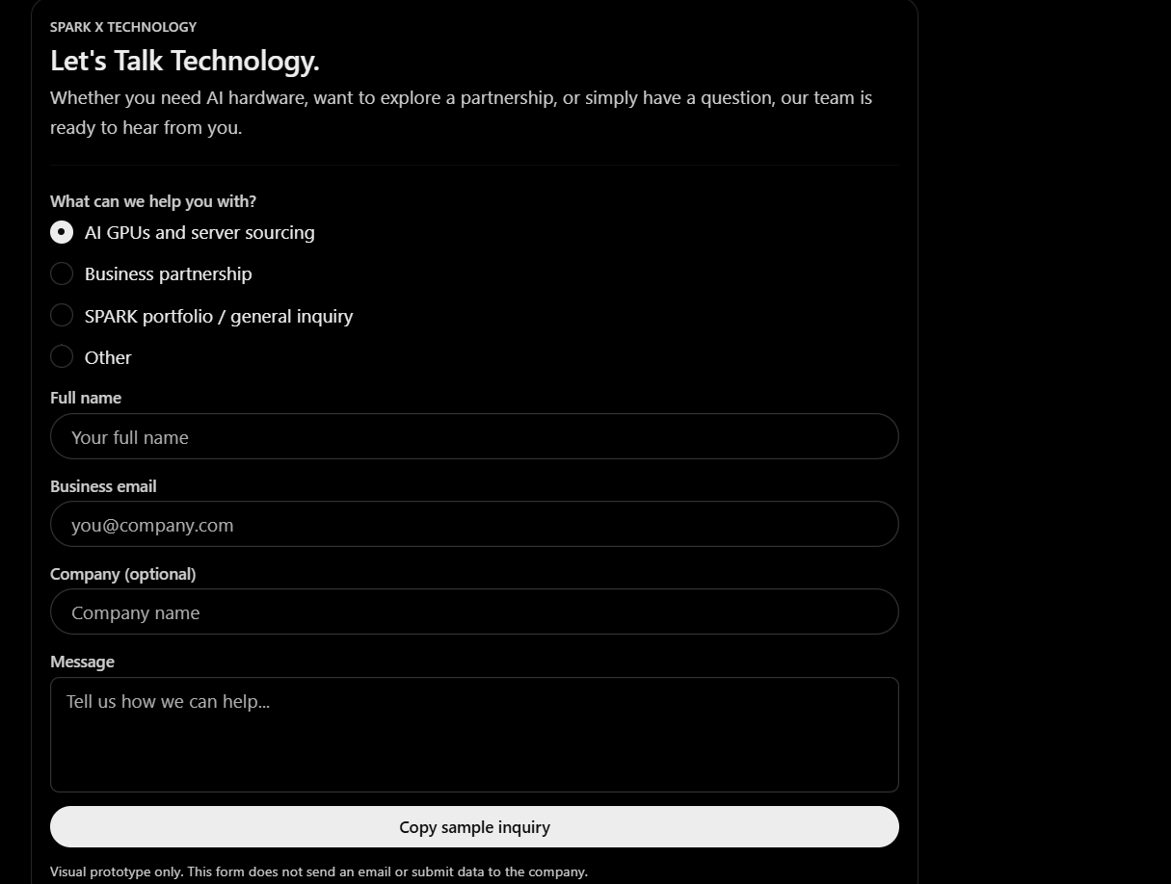

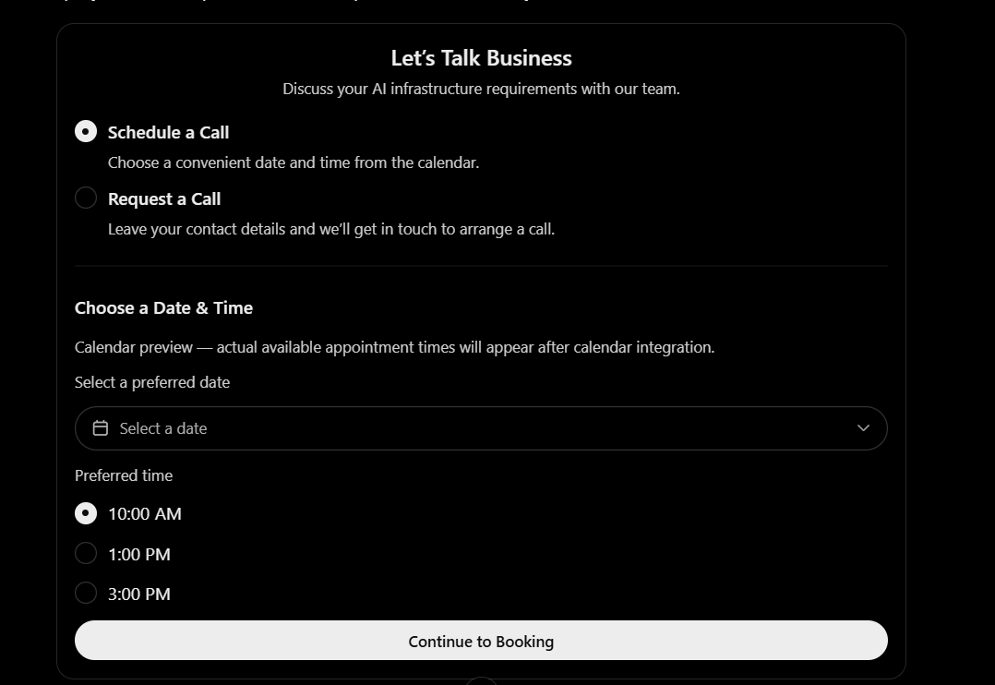

Technical Specification: Request a Call & Schedule a Call
1. Objective
Implement a professional call-booking feature on the SPARK X Technology website, allowing visitors to choose between scheduling a call using a calendar or submitting a callback request without selecting a date or time.
The feature must match the website’s existing design system and work on desktop, tablet, and mobile devices.
2. User Choice
When a visitor clicks “Contact Us” or “Talk to Our Team,” display two options:
Option A: Schedule a Call
- Allow the visitor to select an available date and time from an integrated booking calendar.
- Display only genuinely available appointment slots.
- Show the visitor’s applicable time zone.
- Collect the visitor’s contact information before confirming the booking.
- Send a booking confirmation to the visitor and an email notification to the website administrator.
- Prevent double bookings and handle unavailable slots or booking errors gracefully.
Use Calendly or another suitable scheduling service. The calendar must be connected to a real availability source before it is presented as operational.
Option B: Request a Call
- Allow visitors to request a callback without using a calendar.
- Do not require the visitor to select a date or time.
- Display the message: “Leave your contact details and our team will contact you to arrange a convenient time.”
3. Form Fields
Both options must collect:
- Full Name — required
- Business Email — required
- Phone Number — required
- Company Name — optional
- Country — optional
- Message / Inquiry Details — optional
For Option A, collect the required contact details before finalizing the booking.
For Option B, submit the callback request directly.
4. Request Processing
For every successful submission:
- Generate a unique request ID.
- Save the request securely in the website database or connected CRM.
- Send an email notification to directly888krock@gmail.com.
- Include the request type, request ID, visitor details, submission date and time, and message.
- For scheduled calls, also include the confirmed appointment date, time, and time zone.
- Send the visitor an appropriate confirmation email.
- Display a clear on-screen success message.
- Provide error handling, server-side validation, and spam protection.
Do not display a successful submission message unless the request has actually been processed successfully.
5. Admin Dashboard
Allow the administrator to view and manage all callback requests and scheduled calls.
Include:
- Request ID
- Request type
- Contact details
- Submission timestamp
- Scheduled appointment, if applicable
- Status: New, Contacted, Scheduled, Completed, or Closed
- Internal notes
Keep internal notes and administrative information private.
6. Design Requirements
- Use the existing SPARK X Technology visual identity.
- Maintain the light catalog design, white backgrounds, dark navy typography, and electric-blue accents.
- Use clear buttons: “Schedule a Call” and “Request a Call.”
- Make the booking flow simple and professional.
- Ensure responsive layouts and accessible form controls.
- Avoid requiring customers to create an account.
7. Important Implementation Notes
- The callback form and calendar booking must be separate workflows.
- Do not publish a personal phone number on the website.
- Do not display fabricated availability or placeholder appointment slots as real.
- Do not require a paid scheduling subscription unless approved by the website owner.
- Test both workflows, email delivery, booking confirmation, validation, mobile layouts, and failure scenarios before launch.
8. Acceptance Criteria
The feature is complete when a visitor can successfully schedule an available call or submit a callback request without a calendar, the administrator receives the correct notification, and every request is saved and visible in the admin dashboard.

Business Email Display and Direct Contact
- Display the company's direct business email address on the Contact page and in the website footer.
- Add a clickable “Email Us” link that opens the visitor's default email application using a mailto: link.
- Optionally include an email contact link in the website header or Contact Us menu.
- Use the business email address provided by the website owner. Do not display the administrator's private email unless explicitly approved.
- Keep the public contact email separate from internal notification settings if different addresses are required.
- Ensure that quote requests, callback requests, and general inquiries are also delivered to the configured administrator email address.

Additional might be applied profile of customer:
Dashboard, My Requests, My Quotes, Saved Products, Company Profile, KYB & Compliance и Account Settings

And for this case I would add also admin dashboard to track and see users , orders and etc.

